**System Programming Lab**

**BCSE 3rd year 1st Semester**

**Name: Sayantan Biswas**

**Roll No: 001910501057**

**----------------------------------------------------------------------**

***>> I have done this assignment using emu8086***

* **Assignment 1**

**Q1:**

;Write and test a MASM program to Display your name and program title on the output screen.

.model small

.stack 100h

.data

s1 db "Sayantan Biswas$"

s2 db "a1p01$"

.code

main proc

mov ax,@data ;Getting address of Data Segment

mov ds,ax

lea dx,s1 ;load s1

mov ah,9

int 21h

mov ah,2

mov dl,0dh ;carriage return(\r)

int 21h

mov dl,0ah ;line feed(\n)

int 21h

lea dx,s2 ;load s2

mov ah,9

int 21h

mov ah,4ch ;terminate program

int 21h

main endp

end

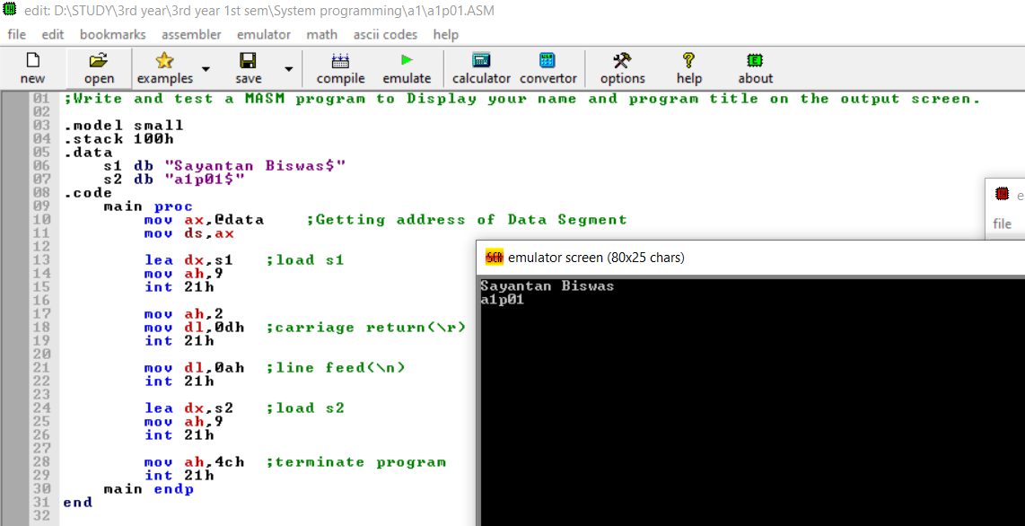

**Q2:**

;Write and test a MASM program to convert a letter from uppercase to lowercase

.model small

.stack 100h

.data

.code

main proc

mov ah,01h ;Takes only one character from user. The input is taken in reg AL

int 21h

add al,32

mov bl,al

mov dl,0ah ;line feed

mov ah,02h ;Displays only single character whose ASCII value is in DL reg

int 21h

mov dl,0dh ;carriage return

mov ah,02h

int 21h

mov dl,bl

mov ah,02h ;Displays only single character whose ASCII value is in DL reg

int 21h

mov ah,4ch

int 21h

main endp

end

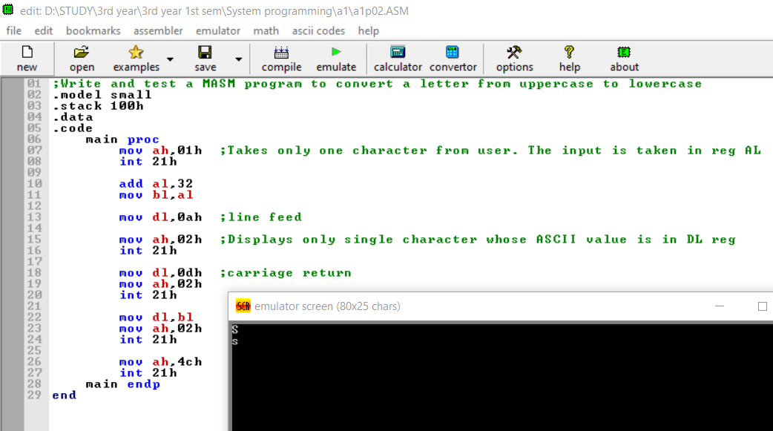

**Q3:**

;Write and test a MASM program to add two Hexadecimal Numbers

.MODEL SMALL

.STACK 100H

.DATA

L1 db 13,10,"Enter the 1st number: $"

L2 db 13,10,"Enter the 2nd number: $"

L3 db 13,10,"The result after addition is: $"

.CODE

MAIN PROC

MOV AX,@DATA

MOV DS,AX

XOR BX,BX ;set BX value to 0

MOV CL,4

LEA DX, L1 ;show L1

MOV AH, 9

INT 21H

MOV AH,1 ;for taking input

INT 21H

INPUT1:

CMP AL,0DH ;compare whether the pressed key is 'ENTER' or not

JE LINE1 ;If it is equal to 'Enter' then stop taking first value. JE = Jump if equal

CMP AL,39H ;compare the input whether it is letter or digit. 39h is the ascii value of 9

JG LETTER1 ;JG = Jump if greater/not less or equal

AND AL,0FH ;if it is digit then convert it's ascii value to real value, clear the high-order bits to zero

JMP SHIFT1

LETTER1: ;if it is letter then subtract 37h from it to find it's real value. 41h is the ASCII code for a letter 'A', (41h - 10d) = (41h - 0Ah) = 37h

SUB AL,37h

SHIFT1:

SHL BX, CL ;shift the bits left

OR BL,AL ;making 'or' to add the current value with previous value

INT 21H

JMP INPUT1

LINE1:

LEA DX, L2 ;show L2

MOV AH, 9

INT 21H

XOR DX,DX ;set DX value zero

MOV AH,1

INT 21H

INPUT2:

CMP AL,0DH ;compare whether the pressed key is 'ENTER' or not

JE LINE2 ;If it is equal to 'Enter' then stop taking first value. JE = Jump if equal

CMP AL,39H ;compare the input whether it is letter or digit. 39h is the ascii value of 9

JG LETTER2 ;JG = Jump if greater/not less or equal

AND AL,0FH ;if it is digit then convert it's ascii value to real value, clear the high-order bits to zero

JMP SHIFT2

LETTER2: ;if it is letter then subtract 37h from it to find it's real value. 41h is the ASCII code for a letter 'A', (41h - 10d) = (41h - 0Ah) = 37h

SUB AL,37H

SHIFT2:

SHL DX, CL

OR DL,AL ;making 'or' to add the current value with previous value

INT 21H

JMP INPUT2

LINE2:

XOR CX,CX

MOV CX,DX

MOV DH,16

SUM:

ADD BX,CX ;add two number which are stored in BX and CX register

JC PC1 ;if the register is overflowed then print an extra 1

mov cl, 4

LEA DX, L3 ;show L3

MOV AH, 9

INT 21H

OUTPUT: ;for printing the sum

MOV CH,BH

SHR CH, CL

AND CH,0FH

CMP CH,10 ;convert decimal to binary

ADD CH,48

CMP CH,':'

JL TAG ;Jump to Label

ADD CH,7

TAG: ; 4 Tags for 4 digit display

MOV DL,CH

MOV AH,2

INT 21H

MOV CH,BH

AND CH,0FH

CMP CH,10

ADD CH,48

CMP CH,':'

JL TAG1

ADD CH,7

TAG1:

MOV DL,CH

MOV AH,2

INT 21H

MOV CH,BL

SHR CH, CL

AND CH,0FH

CMP CH,10

ADD CH,48

CMP CH,':'

JL TAG2

ADD CH,7

TAG2:

MOV DL,CH

MOV AH,2

INT 21H

MOV CH,BL

AND CH,0FH

CMP CH,10

ADD CH,48

CMP CH,':'

JL TAG3

ADD CH,7

TAG3:

MOV DL,CH

MOV AH,2

INT 21H

JMP EXIT

PC1: ;for printing overflowed 1

MOV DL,'1'

MOV AH,2

INT 21H

JMP OUTPUT

EXIT:

MOV AH, 4CH

INT 21H

MAIN ENDP

END MAIN

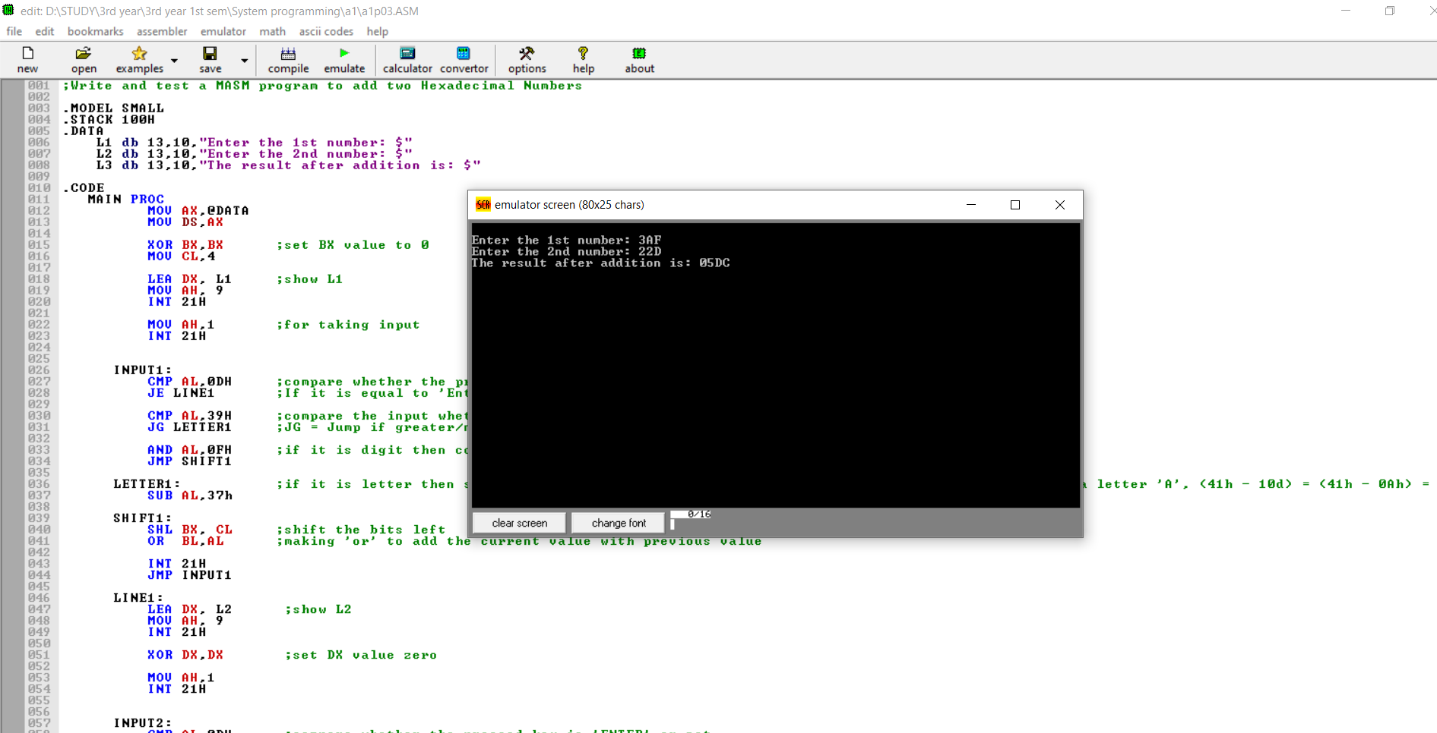

**Q4:**

;Write and test a MASM program to find the second max and second min from an array.

.model small

.stack 100h

.data

prompt_0 db 'enter the number of array elements :',0dh,0ah,'$'

prompt_1 db 'enter the array elements :',0dh,0ah,'$'

prompt_2 db 'the 2nd maximum is : $'

prompt_3 db 'the 2nd minimum is : $'

array dw 50 dup(0)

s dw ?

max dw ?

min dw ?

.code

main proc

mov ax, @data ; initialize ds

mov ds, ax

lea dx, prompt_0 ; load and display the string prompt_0

mov ah, 9

int 21h

mov ah,1 ;for taking input

int 21h

input1:

cmp al,0dh ;compare whether the pressed key is 'enter' or not

je line1 ;if it is equal to 'enter' then stop taking first value

and al,0fh ;convert it's ascii value to real value by masking

shl bx, 1

shl bx, 1

shl bx, 1

shl bx, 1

or bl,al ;making 'or' will add the current value with previous value

int 21h

jmp input1

line1:

lea dx, prompt_1 ; load and display the string prompt_1

mov ah, 9

int 21h

lea si, array ; set si=offset address of array

mov s,bx

mov cx, bx ; set cx=bx

@read_array: ; loop label

mov ah,1 ;for taking input

int 21h

xor dx,dx

input2:

cmp al,0dh ;compare whether the pressed key is 'enter' or not

je line2 ;if it is equal to 'enter' then stop taking first value

and al,0fh ;convert it's ascii value to real value by masking

shl dx,1

shl dx,1

shl dx,1

shl dx,1

or dl,al ;making 'or' will add the current value with previous value

int 21h

jmp input2

line2:

mov [si], dx ; set [si]=ax

add si, 2 ; set si=si+2

mov dl, 0ah ; line feed

mov ah, 2 ; set output function

int 21h ; print a character

loop @read_array ; jump to label @read_array while cx!=0

; array input done

lea si,array

mov ax,bx

dec ax

xor bx,bx

xor cx,cx

mov bx,word ptr[si] ;store the maximum

mov cx,word ptr[si] ;store the 2nd

add si, 2

; loop to find max and 2nd max

arrayloop2:

cmp word ptr[si],bx

jl max2

mov cx,bx

mov bx,word ptr[si]

max2:

cmp word ptr[si],cx

jl incre

cmp word ptr[si],bx

je incre

mov cx,word ptr[si]

incre:

add si, 2

dec ax

jnz arrayloop2

; now bx has max cx has 2nd max

mov max,bx

; displaying the prompt

lea dx,prompt_2

mov ah,09h

int 21h

; display contents of cx

mov bx,cx

mov dh,bh

shr dh, 1

shr dh, 1

shr dh, 1

shr dh, 1

and dh,0fh

add dh,'0'

mov dl,dh

mov ah,2

int 21h

mov dh,bh

and dh,0fh

add dh,'0'

mov dl,dh

mov ah,2

int 21h

mov dh,bl

shr dh, 1

shr dh, 1

shr dh, 1

shr dh, 1

and dh,0fh

add dh,'0'

mov dl,dh

mov ah,2

int 21h

mov dh,bl

and dh,0fh

cmp dh,10

add dh,'0'

mov dl,dh

mov ah,2

int 21h

mov dl, 0ah ; line feed

mov ah, 2 ; set output function

int 21h ; print a character

lea si,array

mov ax,s

dec ax

mov bx,max

; loop to find min and 2nd min

arrayloop3:

cmp word ptr[si],bx

jg min2

mov cx,bx

mov bx,word ptr[si]

min2:

cmp word ptr[si],cx

jg incre2

cmp word ptr[si],bx

je incre2

mov cx,word ptr[si]

incre2:

add si, 2

dec ax

jnz arrayloop3

; now bx has min cx has 2nd min

; displaying the prompt

lea dx,prompt_3

mov ah,09h

int 21h

; display contents of cx

mov bx,cx

mov dh,bh

shr dh, 1

shr dh, 1

shr dh, 1

shr dh, 1

and dh,0fh

add dh,'0'

mov dl,dh

mov ah,2

int 21h

mov dh,bh

and dh,0fh

add dh,'0'

mov dl,dh

mov ah,2

int 21h

mov dh,bl

shr dh, 1

shr dh, 1

shr dh, 1

shr dh, 1

and dh,0fh

add dh,'0'

mov dl,dh

mov ah,2

int 21h

mov dh,bl

and dh,0fh

cmp dh,10

add dh,'0'

mov dl,dh

mov ah,2

int 21h

exit:

mov ah, 4ch ;return control to dos

int 21h

main endp

end main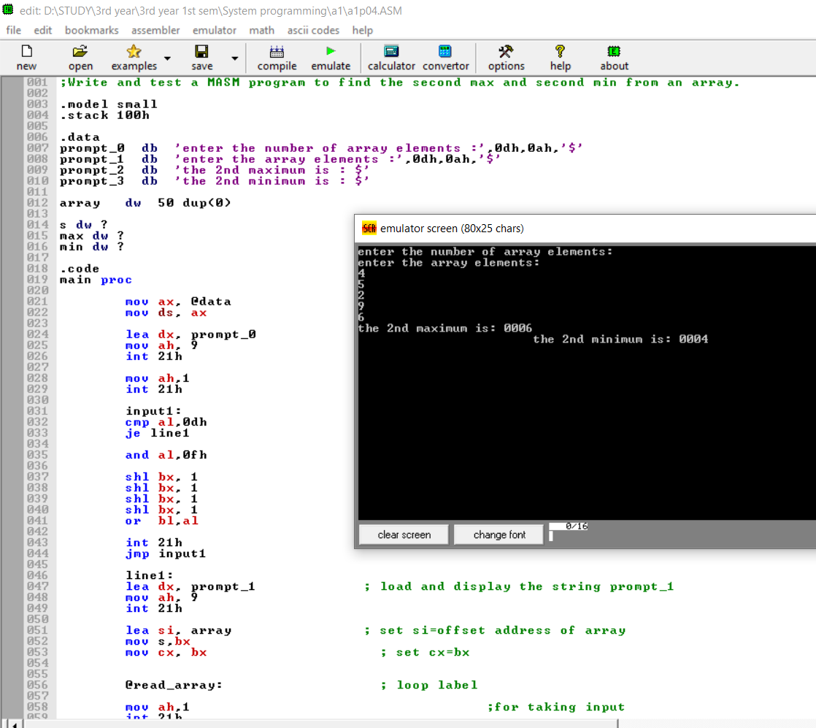

**Q5:**

; Write and test a MASM program to display a terminating message

.MODEL SMALL

.STACK 100H

.DATA

S1 DB 'Press Enter to terminate the program$'

S2 DB 'Terminating...$'

.CODE

MAIN PROC

MOV AX,@DATA

MOV DS,AX

LEA DX, S1

MOV AH,9 ; Displays a message terminated by “$”

INT 21H

MOV AH,1 ;Takes only one character from user. The input is taken in reg AL

INT 21H

MOV BL,AL

MOV AH,2 ;cursor position

MOV DL,0DH ;carriage return

INT 21H

MOV DL,0AH ;line feed

INT 21H

LEA DX, S2

MOV AH,9

INT 21H

MOV AH,4CH

INT 21H

MAIN ENDP

END MAIN

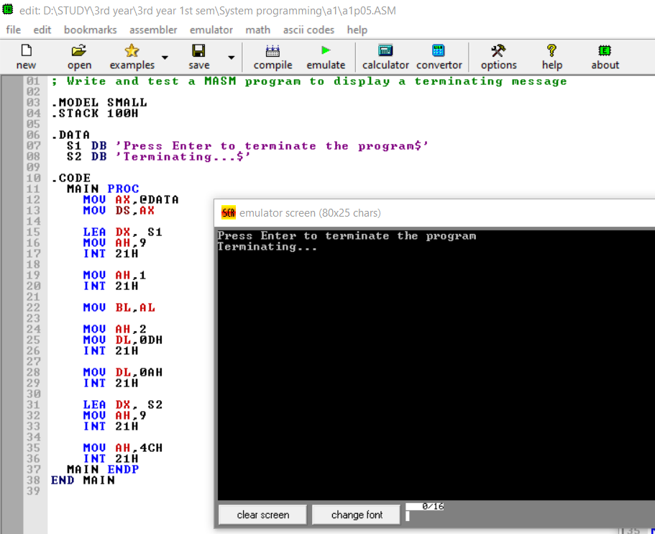

**Q6:**

; Write and test a MASM program to Take a character from the keyboard and print it.

.MODEL SMALL

.STACK 100H

.DATA

.CODE

MAIN PROC

MOV AH,01H ;Takes only one character from user

INT 21H

MOV BL,AL

MOV DL,0AH

MOV AH,02H

INT 21H

MOV DL,0DH

MOV AH,02H

INT 21H

MOV DL,BL

MOV AH,02H

INT 21H

MOV AH,4CH

INT 21H

MAIN ENDP

END

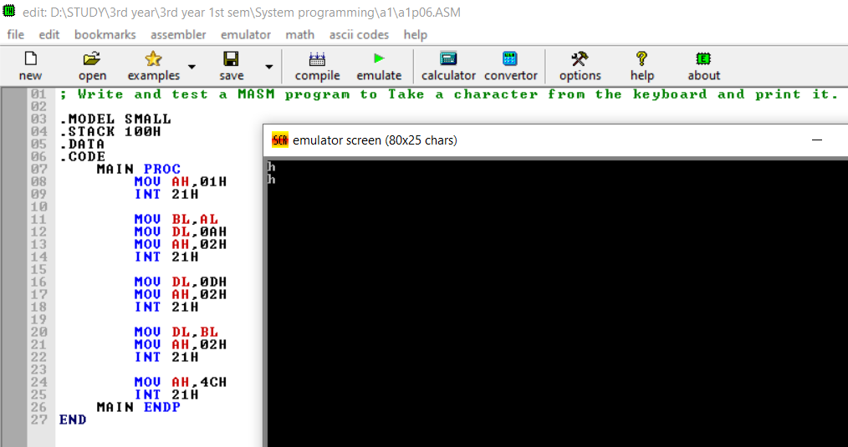

**Q7:**

; Write and test a MASM program to validate second numbers is less than the first.

.MODEL SMALL

.STACK 100H

.DATA

S1 DB 0AH,0DH,"Enter 1st number: $"

S2 DB 0AH,0DH,"Enter 2nd number: $"

S3 DB 0AH,0DH,"2nd number is less than 1st number$"

S4 DB 0AH,0DH,"2nd number is greater than 1st number$"

S5 DB 0AH,0DH,"Two numbers are equal$"

.CODE

MAIN PROC

MOV AX,@DATA

MOV DS,AX

LEA DX,S1

MOV AH,09H

INT 21H

MOV AH,01H ;takes one input

INT 21H

MOV BL,AL

LEA DX,S2

MOV AH,09H

INT 21H

MOV AH,01H

INT 21H

CMP BL,AL

JG COND1

JL COND2

LEA DX,S5

MOV AH,09H

INT 21H

MOV AH,4CH

INT 21H

COND1:

LEA DX,S3

MOV AH,09H

INT 21H

MOV AH,4CH

INT 21H

COND2:

LEA DX,S4

MOV AH,09H

INT 21H

MOV AH,4CH

INT 21H

MAIN ENDP

END

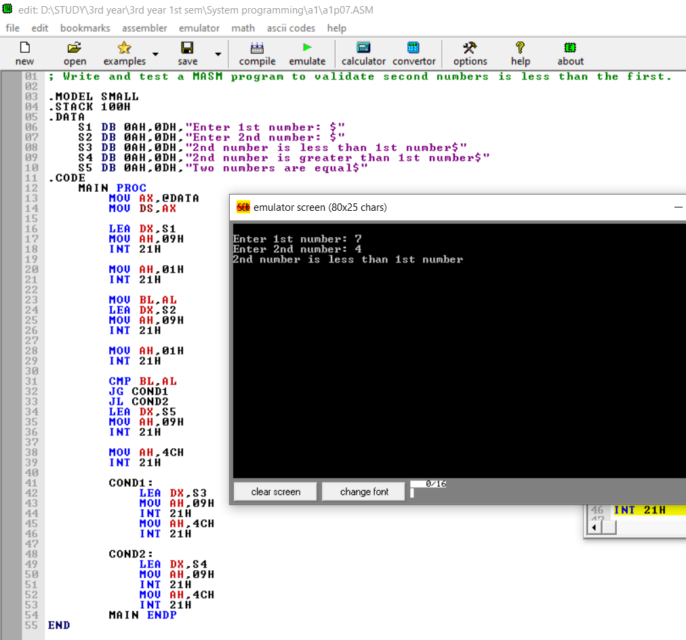

**Q8:**

;Write and test a MASM program to find maximum and minimum from an array.

.model small

.stack 100h

.data

prompt_0 db 'enter the number of array elements :',0dh,0ah,'$'

prompt_1 db 'enter the array elements :',0dh,0ah,'$'

prompt_2 db 'the maximum is : $'

prompt_3 db 'the minimum is : $'

array dw 50 dup(0)

s dw ?

.code

main proc

mov ax, @data ; initialize ds

mov ds, ax

lea dx, prompt_0 ; load and display the string prompt_0

mov ah, 9

int 21h

mov ah,1 ;for taking input

int 21h

input1:

cmp al,0dh ;compare whether the pressed key is 'enter' or not

je line1 ;if it is equal to 'enter' then stop taking first value

and al,0fh ;convert it's ascii value to real value by masking

shl bx, 1

shl bx, 1

shl bx, 1

shl bx, 1

or bl,al ;making 'or' will add the current value with previous value

int 21h

jmp input1

line1:

lea dx, prompt_1 ; load and display the string prompt_1

mov ah, 9

int 21h

lea si, array ; set si=offset address of array

mov cx, bx ; set cx=bx

@read_array: ; loop label

mov ah,1 ;for taking input

int 21h

xor dx,dx

input2:

cmp al,0dh ;compare whether the pressed key is 'enter' or not

je line2 ;if it is equal to 'enter' then stop taking first value

and al,0fh ;convert it's ascii value to real value by masking

shl dx,1

shl dx,1

shl dx,1

shl dx,1

or dl,al ;making 'or' will add the current value with previous value

int 21h

jmp input2

line2:

mov [si], dx ; set [si]=ax

add si, 2 ; set si=si+2

mov dl, 0ah ; line feed

mov ah, 2 ; set output function

int 21h ; print a character

loop @read_array ; jump to label @read_array while cx!=0

; array input done

lea si,array

mov ax,bx

dec ax

xor bx,bx

xor cx,cx

mov bx,word ptr[si] ;store the maximum

mov cx,word ptr[si] ;store the minimum

add si, 2

; loop to find max and min

arrayloop2:

cmp word ptr[si],bx

jg maximum

cmp word ptr[si],cx

jl minimum

jmp incre

maximum:

mov bx,word ptr[si]

jmp incre

minimum:

mov cx,word ptr[si]

incre:

add si, 2

dec ax

jnz arrayloop2

; displaying the prompt

lea dx,prompt_2

mov ah,09h

int 21h

; display contents of bx

output: ;level for printing their sum

mov dh,bh

shr dh, 1

shr dh, 1

shr dh, 1

shr dh, 1

and dh,0fh

add dh,'0'

mov dl,dh

mov ah,2

int 21h

mov dh,bh

and dh,0fh

add dh,'0'

mov dl,dh

mov ah,2

int 21h

mov dh,bl

shr dh, 1

shr dh, 1

shr dh, 1

shr dh, 1

and dh,0fh

add dh,'0'

mov dl,dh

mov ah,2

int 21h

mov dh,bl

and dh,0fh

cmp dh,10

add dh,'0'

mov dl,dh

mov ah,2

int 21h

mov dl, 0ah ; line feed

mov ah, 2 ; set output function

int 21h ; print a character

; displaying the prompt

lea dx,prompt_3

mov ah,09h

int 21h

; display contents of cx

mov bx,cx

mov dh,bh

shr dh, 1

shr dh, 1

shr dh, 1

shr dh, 1

and dh,0fh

add dh,'0'

mov dl,dh

mov ah,2

int 21h

mov dh,bh

and dh,0fh

add dh,'0'

mov dl,dh

mov ah,2

int 21h

mov dh,bl

shr dh, 1

shr dh, 1

shr dh, 1

shr dh, 1

and dh,0fh

add dh,'0'

mov dl,dh

mov ah,2

int 21h

mov dh,bl

and dh,0fh

cmp dh,10

add dh,'0'

mov dl,dh

mov ah,2

int 21h

exit:

mov ah, 4ch ;return control to dos

int 21h

main endp

end main

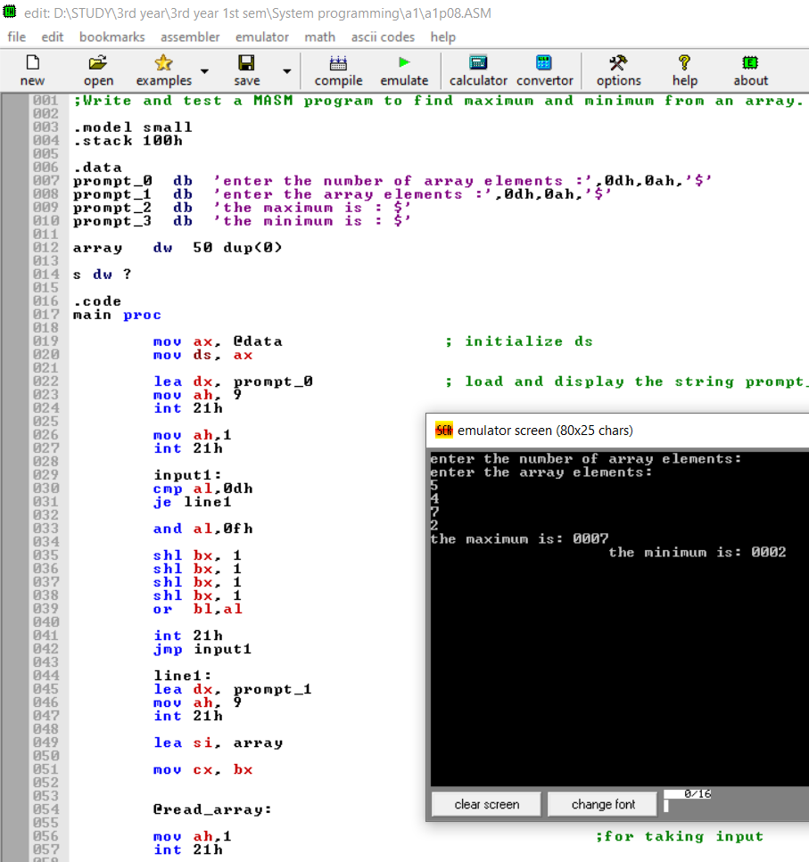

**Q9:**

;Write and test a MASM program to loop until the user decides to quit

.MODEL SMALL

.STACK 100H

.DATA

S1 DB 10,13,"Enter Q to quit or any other to continue loop: $"

S2 DB 10,13,"LOOP$"

.CODE

MAIN PROC

MOV AX,@DATA

MOV DS,AX

LABEL1:

LEA DX,S2

MOV AH,09H

INT 21H

LEA DX,S1

MOV AH,09H

INT 21H

MOV AH,01H ;accept a character

INT 21H

CMP AL,'Q' ;check if chacracter is Q, (uppercase)

JNE LABEL1

MOV AH,4CH

INT 21H

MAIN ENDP

END MAIN

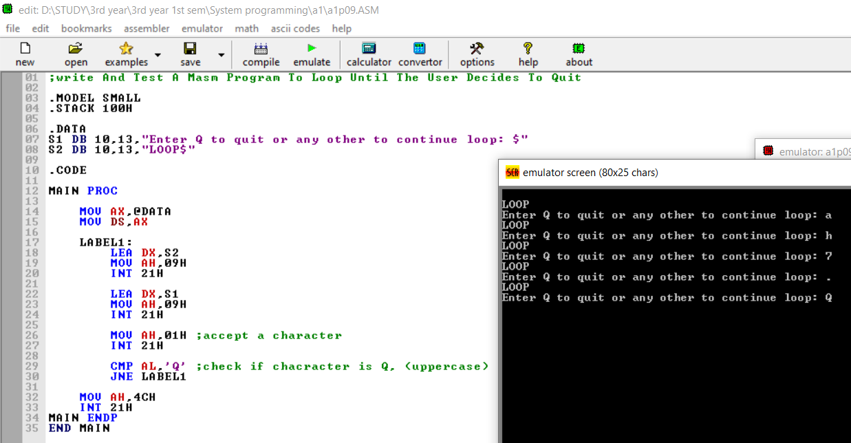

**Q10:**

; Write and test a MASM program to print all the characters from A-Z.

.MODEL SMALL

.STACK 100H

.DATA

SPACE DB ‘ ‘

.CODE

MAIN PROC

MOV AX,@DATA

MOV DS,AX

MOV BX,65

MOV CX,0

LABEL1:

MOV AH,02H ;print A-Z

MOV DL,BL

INT 21H

MOV AH,02H ;print spaces

MOV DL,SPACE

INT 21H

INC BX

INC CX

CMP CX,26 ;compare if space count is 26

JNE LABEL1

MOV AH,4CH

INT 21H

MAIN ENDP

END



